

**Joshua David, Amanda Leigh, David John, Nancy Jean Kramer, Jessica Anne, Natalie Marie - all Lists – 2001**

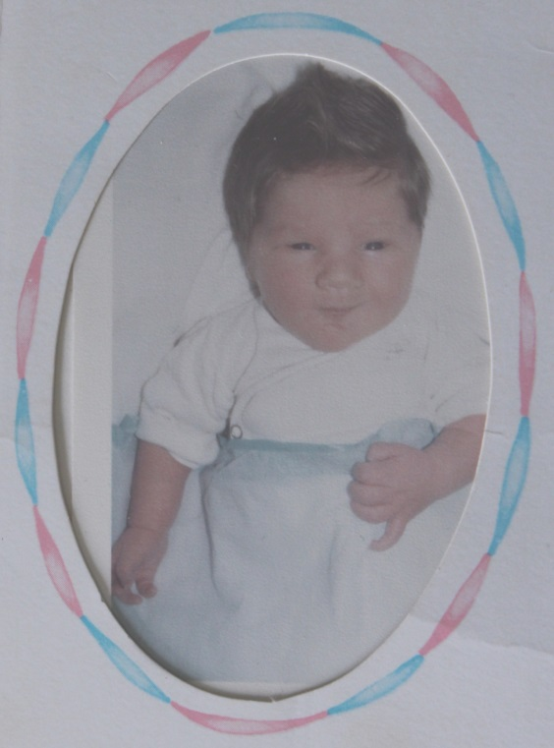

**Nathaniel James List, s/o David John & Nancy Kramer List**

**31 Jul 1980-14 Nov 1980**